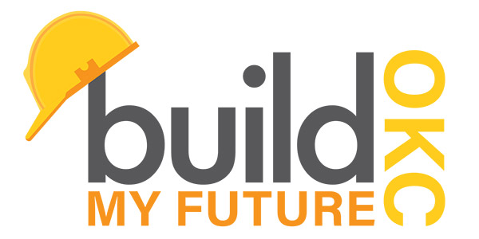

|  |
| --- |
| **2019 Sponsorship Information** |

**Build My Future**Construction Career Day & Education Program For Students *April 3, 2019 at Oklahoma Expo Hall-Oklahoma State Fairgrounds,*

*300 General Pershing Blvd., OKC, OK 73107*

***9 am – 2 pm Participating Students*** Build My Future is an interactive forum that connects students to the education programs and opportunities available in the construction industry. During the day, students and teachers will engage in approx. five hours of hands-on activities facilitated by industry professionals.

Activities include learning labs/safety training, equipment operations, and educational displays.   
Build My Future is for school administrators and parents of participating students

|  |  |  |  |  |  |
| --- | --- | --- | --- | --- | --- |
| 1. **Sponsorships** | | | | | |
| **Level** | **Program** | **Master** | **Journeyman** | **Apprentice** | **Friend of Industry** |
| **Amount** | **$10,000** | **$5,000** | **$2,500** | **$1,000** | **$500** |
| Sponsorships may be purchased by completing the Sponsorship Registration Form and returning with payment to the **Oklahoma Home Builders Foundation** at 420 E. Britton Road, OKC, OK 73114-7515. Accepted payment methods are invoice (HBA members only), check made payable to the Oklahoma Home Builders Foundation, or credit card. *No refunds or exchanges given for sponsorship donations.* | | | | | |
| 1. **Learning Lab / Equipment** | | | | | |
| A learning lab is where students have a hands-on experience with employment opportunities in the construction industry, such as surveying, concrete mixing and testing, framing, bricklaying, paint labs, welding simulations, etc. *Since the donation of a learning lab/equipment is a heavy time and/or materials commitment, your company will automatically be listed as a sponsor.* | | | | | |
| 1. **Donations of Giveaways and Prizes** | | | | | |
| Donations, large or small, such as gift certificates, discount coupons, admission tickets, promotional merchandise, etc., may be used as giveaway prizes for student participation or for sway bags distributed to approximately 1,500 students throughout the event. *Depending on the value of the gifts donated your company will be displayed as a sponsor per the sponsorship levels shown above.* | | | | | |

All sponsorships and donations to the Build My Future will be processed by the Oklahoma Home Builders Foundation (501 © 3). For more information about Build My Future OKC sponsorship opportunities, please visit <http://buildmyfutureokc.com> or contact Cecilia Bridge at 923-0259.

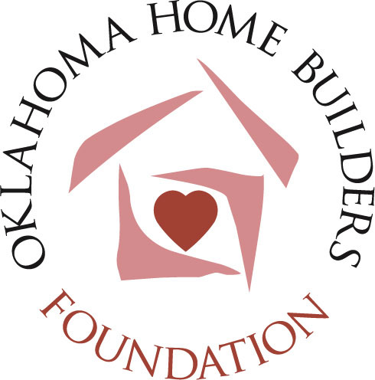You may also contact Kathy Holman at COHBA (405) 843-1508 or Marla Esser Cloos 1(314) 740-7251. For more information about the Build My Future or sponsorship opportunities, please visit <http://buildmyfutureokc.com> or contact Kathy Holman at 405.843.1508, or kathy@cohba.org or Marla Esser Cloos at 1.314.740.7251.