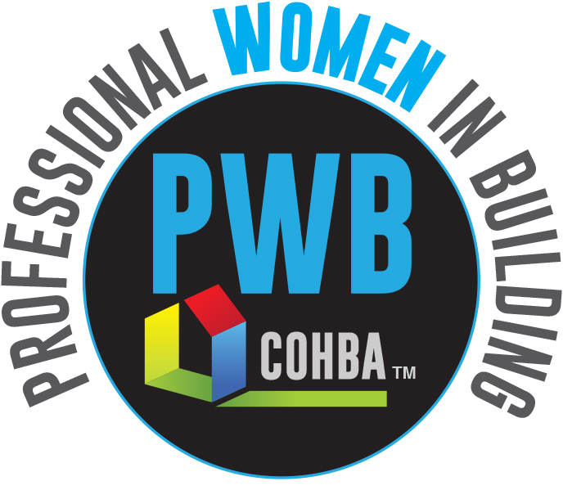

All sponsorships and donations to the Build My Future OKC will be processed by the Oklahoma Home Builders Foundation (501 © 3). For more information about Build My Future OKC sponsorship opportunities, please visit <http://buildmyfutureokc.com> or contact Cecilia Bridge at 923-0259. You may also contact Kathy Holman at COHBA (405) 843-1508 or Marla Esser Cloos 1(314) 740-7251.

Thank you for participating in the first Build My Future OKC

Construction Career Day & Education Program for Students

April 3, 2019 at the Oklahoma Expo Hall – Oklahoma State Fair Park

3001 General Pershing Blvd, Oklahoma City, OK 73107

*9 am – 2 pm Participating Students*



Complete and return Sponsorship Registration form by mail, fax or email.

**Make payment to:**

**Oklahoma Home Builders Foundation**

**420 East Britton Road**

**Oklahoma City, OK 73114-7515**

**Fax: (405) 8436714 Email:** [**kathy@cohba.org**](mailto:kathy@cohba.org) **at COHBA**

 Invoice (HBA members only)  Check Enclosed  Credit Card

**Payment Method:**

 Program ($10,000)  Master ($5,000)  Journeyman ($2,500)

 Apprentice ($1,000)   Friend of the Industry ($500)   (Other): _________

**Sponsorship Level:**

 Contractor  Association  Education/Training  Equipment

 Other (Please explain): ________________________________________________________________________________

**Please check one:**

Company: _________________________________________________ Contact Name: _____________________________________

Address: ______________________________________________ City/State/Zip: __________________________________________

Phone: ______________________________________ Email: ______________________________________________________________

**2019 Sponsorship Registration Form**